Functional Report

**Login**

The login page is used to gain access to the other parts of the website, without having logged in you are only able to access the login and register page. This is done by first making a html form with buttons and input areas. Once the submit button is pressed the PHP code gets run, this code first checks whether both inputs have been filled in, if not you are displayed an error and redirected back to the login page, if successful, the username and password get compared to the database data. If the data is the same, you are redirected to the index page and if the data is not right you are shown an error once again and redirected once again.

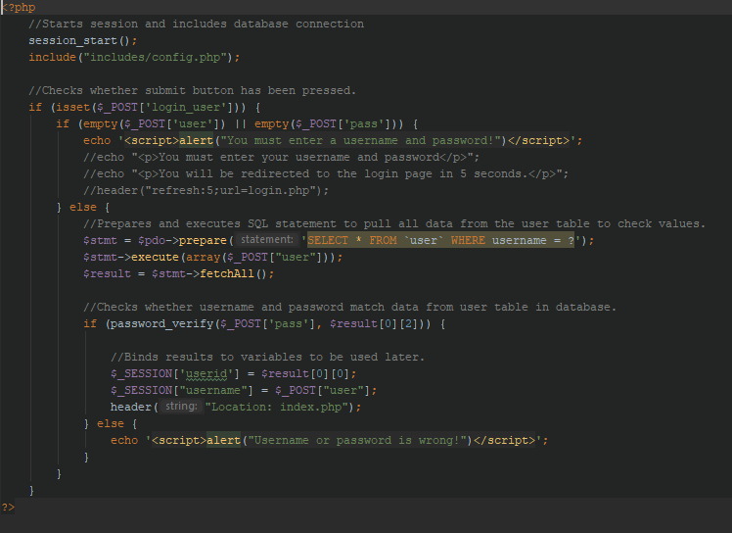

**Register**

The register page is used to create an account, so you can login in and gain access to the other pages. This is done by first making an html form with buttons, input areas and an image uploader. Once the submit button is pressed the PHP code gets run checking if the input fields have been filled in, if not redirecting you, if successful, every field gets inserted into the database and uploads the image hash into the server. If everything is successful you will be redirected to the login page.

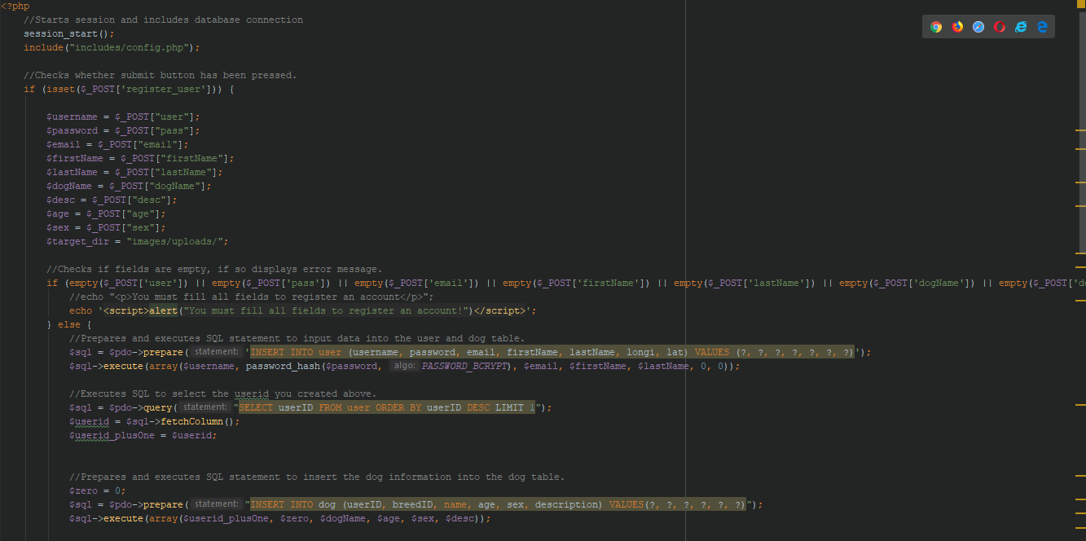

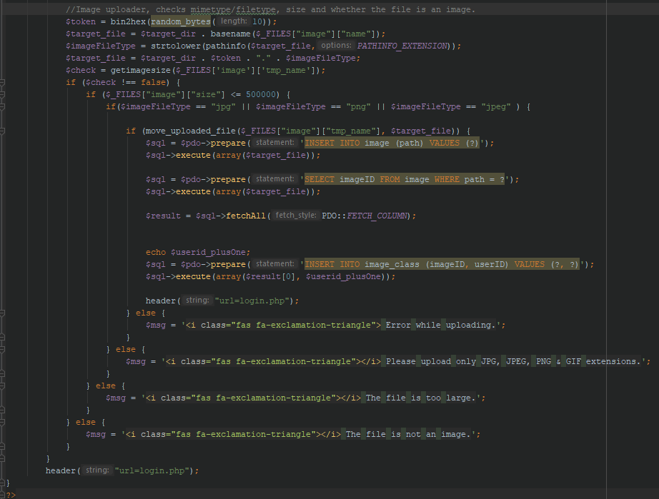

**Preferences/Settings**

The preferences/settings page is used to set your preferences for the type of dogs you’re looking for, these include breed, sex, age and distance. This is done by first making a html form with buttons and input areas. Once the submit button is pressed the PHP code gets run, this code first checks whether all inputs have been filled in, if not you receive an error and if you did the data gets saved to the database to used in the swiping page, so you can only swipe for dogs matching your preferences.

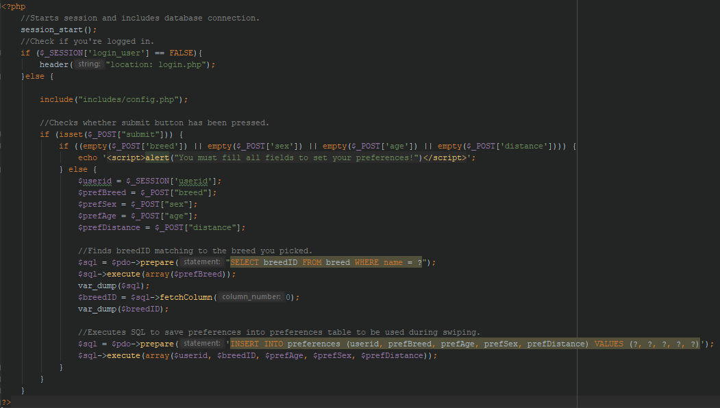

**Profile**

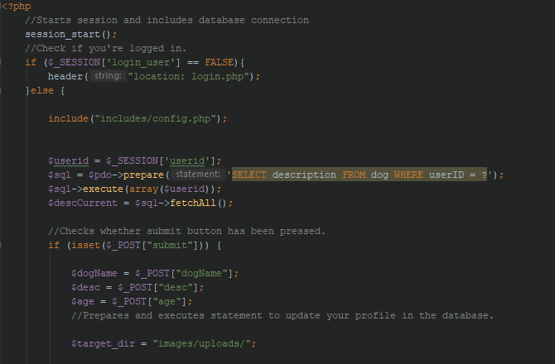The preference page is used change or set certain parts of your profile including: age, dog name, description and gives you the opportunity to upload a new profile page. This is done by first making a html form with buttons and input areas. Once the submit button is pressed the PHP code gets run, this code first checks which inputs have been filled in as not all have to be filled in, depending on what you filled in, the data inputted will be uploaded to the database or server.

